TECHNOLOGY NAME : INTERNET OF THINGS

TITLE : FLOOD MONITORING AND EARLY WARNING SYSTEM

PROBLEM DESCRIPTION:

Floods are natural disasters that can cause extensive damage to property, infrastructure, and loss of lives. Developing an effective Flood Monitoring and Early Warning System (FMEWS) is essential to minimize the impact of floods on communities and the environment.

This system aims to provide timely and accurate flood-related information to enable proactive decision-making, preparedness, and response by governments, emergency services, and affected communities.

1.Early Warning and Preparedness: Provide early detection of potential flooding events to enable timely evacuation and preparedness activities, reducing the risk to human life and property.

2.Real-Time Monitoring: Continuously monitor water levels, rainfall, and other relevant data in flood-prone areas to provide up-to-date information to authorities and the public.

3.Data Collection and Analysis: Gather and analyze hydrological and meteorological data to predict and understand flood patterns, aiding in risk assessment and mitigation planning.

4.Mitigation and Response: Support emergency response efforts by providing accurate information on the extent and severity of flooding, helping authorities allocate resources effectively.

5.Community Engagement: Engage with local communities to increase awareness of flood risks and empower residents to take appropriate precautions during flood events.

COMPONENTS:

* IoT Sensors: These can be ultrasonic sensors, pressure sensors, or float switches to measure the water level in rivers, streams, or flood-prone areas.
* Rainfall sensors: These measure rainfall intensity and can help predict potential flooding.
* Microcontrollers (e.g., Arduino, Raspberry Pi): These collect data from sensors and send it to a central processing unit.
* Communication modules (e.g., GSM, Wi-Fi, LoRa): To transmit the collected data to a central server or database for analysis.
* Mobile application for user interaction.
* Emergency notification system.

DESIGN THINKING:

Central Processing Unit :

* + Server or cloud platform: To receive, store, and analyze the data from the sensors.
  + Data processing software: To analyze the incoming data, trigger alerts, and generate flood predictions.

User Interface:

* + Web or mobile app: Provides real-time information, alerts, and visualizations to users and authorities.
  + Dashboard: A graphical interface to display flood data, forecasts, and historical information.

Alerting System:

* SMS, email, or push notifications: To alert authorities and residents about potential floods or rising water levels.

Power supply:

* Reliable power source or backup (e.g., solar panels, batteries) to ensure continuous operation.

Geographic Information System (GIS):

* Integration with GIS tools for mapping and visualization of flood-prone areas.

Weather Data:

* Access to weather forecasts and data for improved flood prediction.

Remote Access and Control:

* Remote monitoring and control capabilities to manage the system remotely.

Emergency Response Plan:

* Protocols for how to respond to flood alerts, including evacuation procedures and communication channels with local authorities.

Networking and Connectivity:

* Reliable internet or cellular connectivity to transmit data in real-time.

Security Measures:

* Cybersecurity measures to protect the system from potential threats or hacking attempts.

Flow chart:

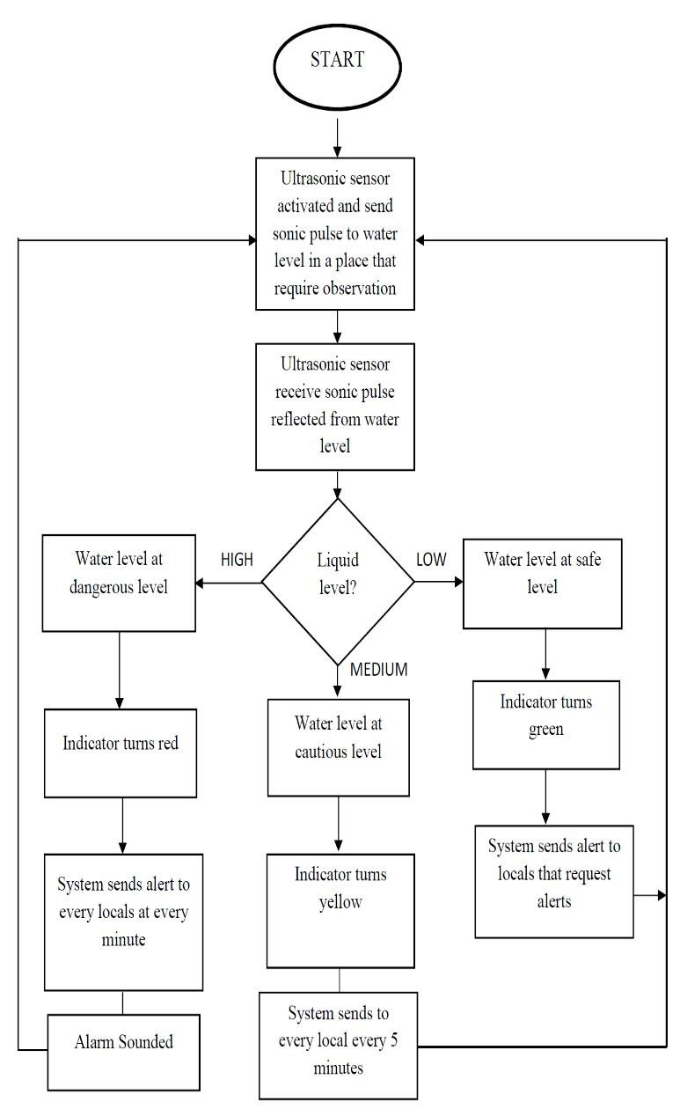

Team members:

L.Dharshini

M.Maha Swetha

P.Nathiya

G.Roobini

M.nazreen